# PCB making guideline

1. Use Fritzing to design PCB – use extra thick wire

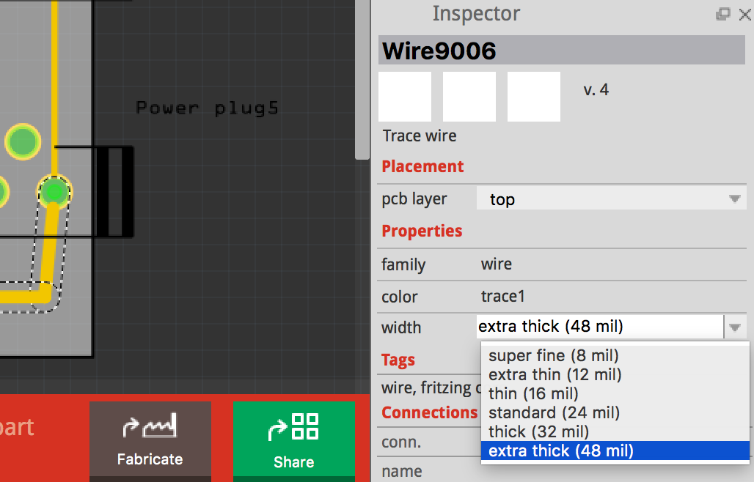

1. (make folder first) Export. svg file

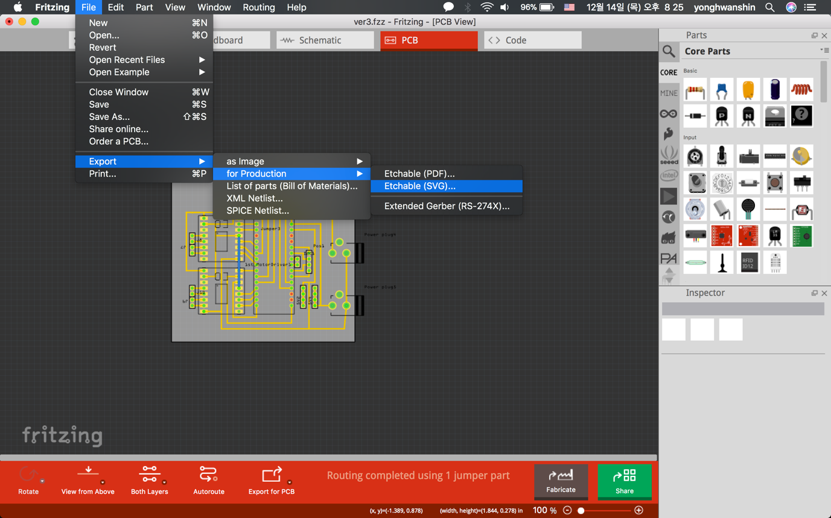

1. Select two files;
2. FILENAME_etch_copper_top_mirror.svg
3. FILENAME_etch_mask_top_mirror.svg
4. Open first file; FILENAME_etch_copper_top_mirror.svg
5. Ungroup all parts (command + shift + g)
6. Remove nothing but lines and circles
7. Fill in every circle in black colour and remove outline
8. Resize every circle in 2mm diameter   
   (1.473 –> 135%, 1.346 –> 150%)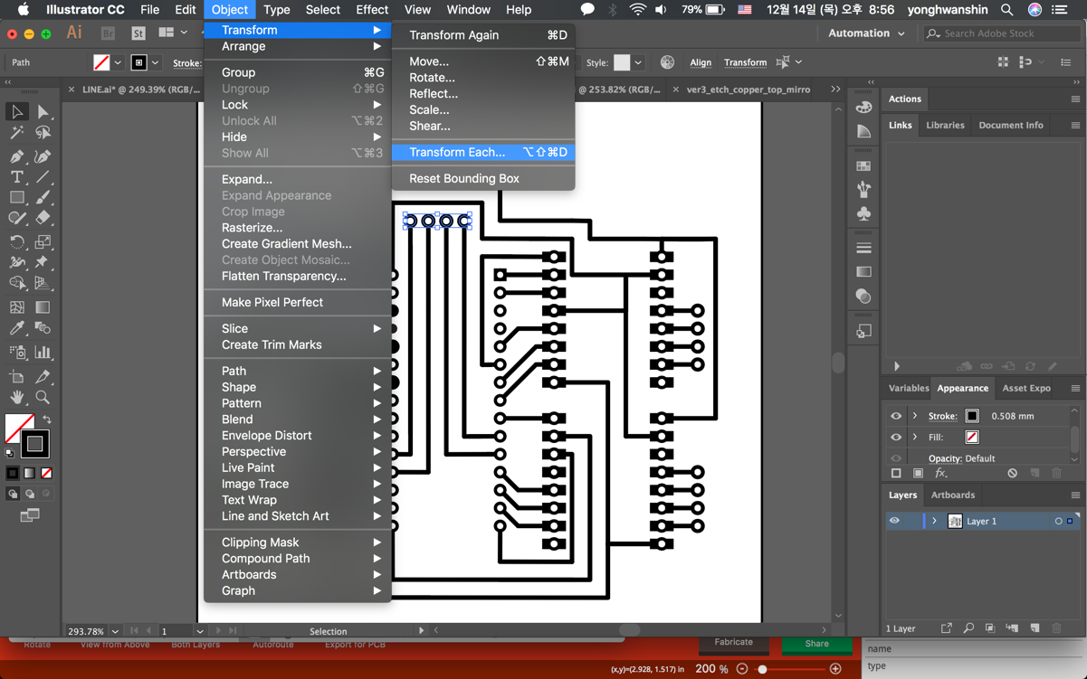 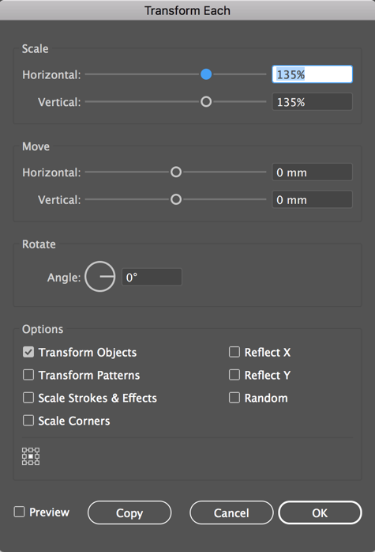
9. Divide image file in few layers not to over 15-minute max.
10. Open second file; FILENAME_etch_mask_top_mirror.svg
11. Ungroup all parts
12. Remove nothing but circles
13. Remove outline
14. Resize every circle in 1mm diameter  
    (1.473 -> 68%, 1.346 -> 75%)
15. Add one additional layer to make PCB outline.  
    make square - same size as PCB – with empty inside.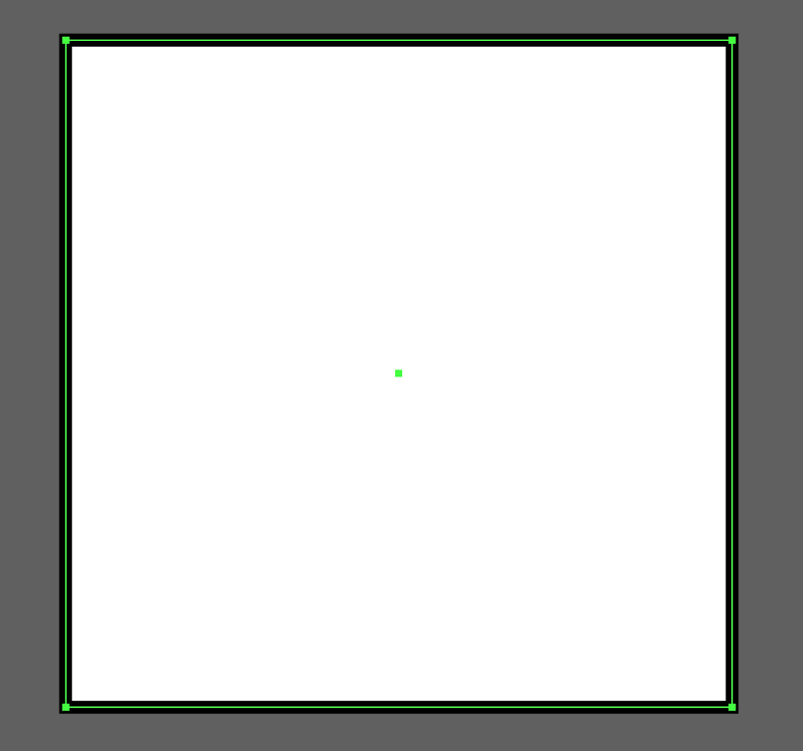
16. Divide image file in few layers not to over 15-minute max.